Isosceles Obtuse Triangle
# Source: AI Source: Provided by: [Data Path: Persons Table -> ID Column: 1, Name_En Column: Motasem Essam] -> From: [ChatGPT] on [7/25/2026]
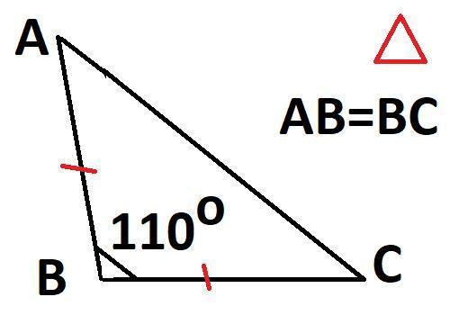
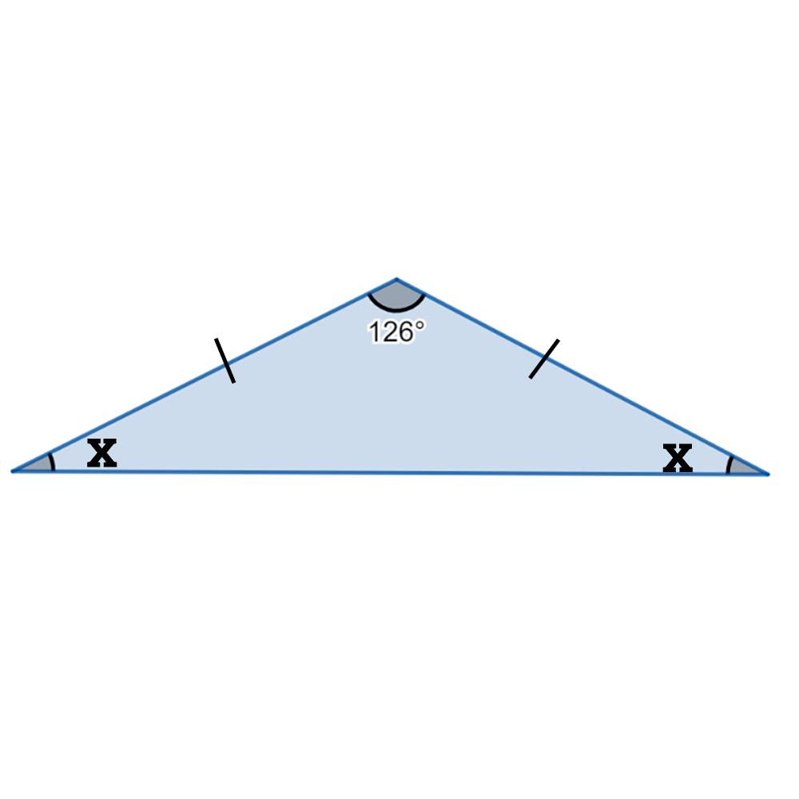
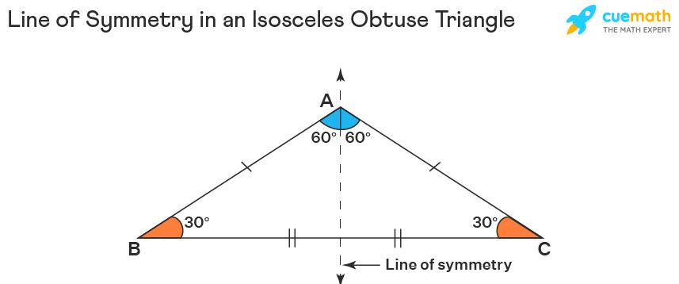
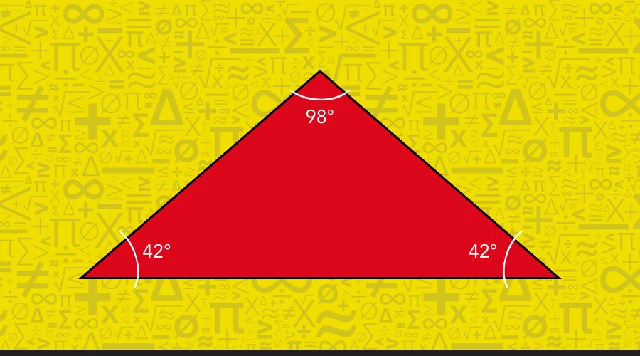
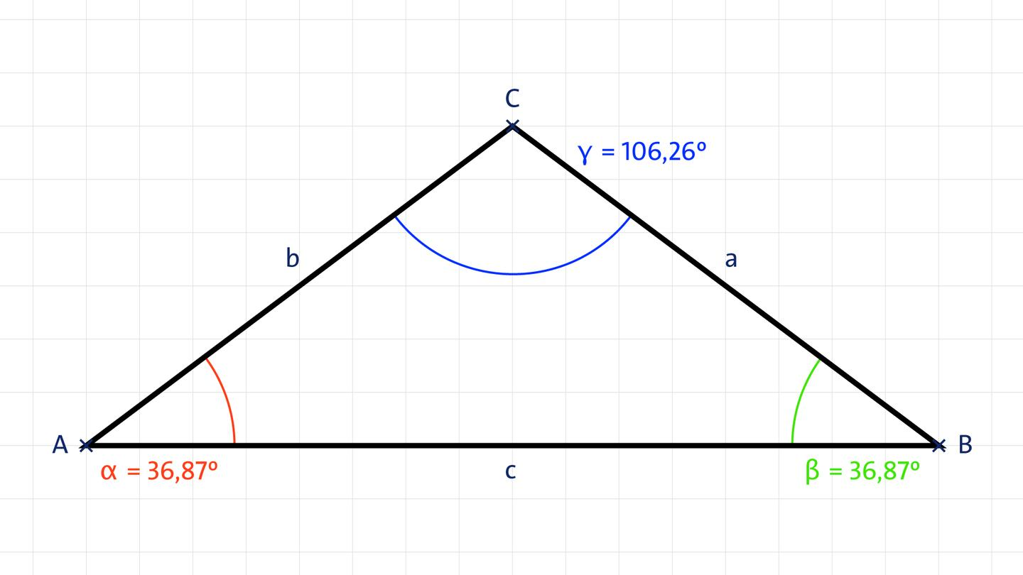

Definition
# Source: AI Source: Provided by: [Data Path: Persons Table -> ID Column: 1, Name_En Column: Motasem Essam] -> From: [ChatGPT] on [7/25/2026]
An Isosceles Obtuse Triangle is a triangle that has:
- At least two equal sides, and
- Exactly one obtuse angle, meaning one interior angle is greater than ${90}^{∘}$and less than ${180}^{∘}$.
Under the common elementary convention that an isosceles triangle has exactly two equal sides, an isosceles obtuse triangle has exactly two equal sides.

Fundamental Properties
# Source: AI Source: Provided by: [Data Path: Persons Table -> ID Column: 1, Name_En Column: Motasem Essam] -> From: [ChatGPT] on [7/25/2026]
Consider an isosceles triangle $ABC$where
$$\boxed{AB=AC}$$
and $BC$is the base.
Then the angles opposite the equal sides are equal:
$$\boxed{∠B=∠C}$$
Since the triangle is obtuse, the unequal vertex angle must be the obtuse angle:
$$\boxed{∠A>{90}^{∘}}$$
and
$$\boxed{∠B=∠C<{45}^{∘}}$$
because
$$∠A+∠B+∠C={180}^{∘}.$$
Therefore:
$$\boxed{{90}^{∘}<∠A<{180}^{∘}}$$
and
$$\boxed{0^{∘}<∠B=∠C<{45}^{∘}}$$

Angle Structure
# Source: AI Source: Provided by: [Data Path: Persons Table -> ID Column: 1, Name_En Column: Motasem Essam] -> From: [ChatGPT] on [7/25/2026]
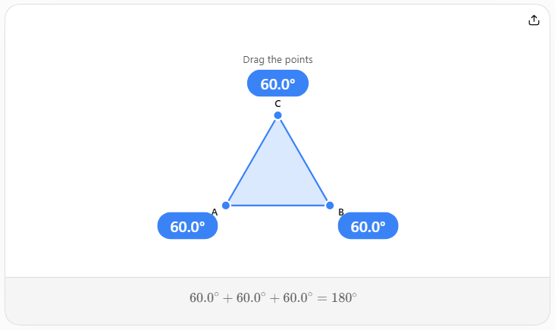
For an isosceles obtuse triangle:
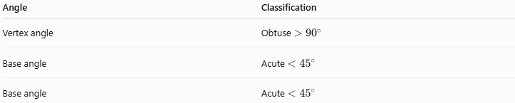
Angle | Classification
Vertex angle | Obtuse $>{90}^{∘}$
Base angle | Acute $<{45}^{∘}$
Base angle | Acute $<{45}^{∘}$
The three angles always satisfy:
$$\boxed{∠A+∠B+∠C={180}^{∘}}$$
Since $∠B=∠C$:
$$\boxed{∠B=∠C=\frac{{180}^{∘}-∠A}{2}}$$

Side Structure
# Source: AI Source: Provided by: [Data Path: Persons Table -> ID Column: 1, Name_En Column: Motasem Essam] -> From: [ChatGPT] on [7/25/2026]
If
$$AB=AC=a$$
and
$$BC=b,$$
then $AB$and $AC$are the equal legs, while $BC$is the base.
Because the largest angle is $∠A$, the side opposite it, $BC$, is the longest side:
$$\boxed{BC>AB=AC}$$
Thus, for an isosceles obtuse triangle:
$$\boxed{b>a}$$

Important Side Condition
# Source: AI Source: Provided by: [Data Path: Persons Table -> ID Column: 1, Name_En Column: Motasem Essam] -> From: [ChatGPT] on [7/25/2026]
Using the Law of Cosines:
$$b^{2}=a^{2}+a^{2}-2a^{2}\cos{A}$$
so
$$\boxed{b^{2}=2a^{2}\left(1-\cos{A}\right)}$$
Because $A>{90}^{∘}$,
$$\cos{A}<0$$
and therefore:
$$\boxed{b^{2}>2a^{2}}$$
or
$$\boxed{b>a\sqrt{2}}$$
This is an especially useful way to identify an isosceles obtuse triangle from its side lengths.

Symmetry
# Source: AI Source: Provided by: [Data Path: Persons Table -> ID Column: 1, Name_En Column: Motasem Essam] -> From: [ChatGPT] on [7/25/2026]
An isosceles obtuse triangle has one line of symmetry when it is not equilateral.
The symmetry axis passes through:
- the vertex of the obtuse angle,
- the midpoint of the base,
- the altitude,
- the median,
- the angle bisector,
- the perpendicular bisector of the base.
Therefore, these segments/lines coincide:
$$\boxed{\text{Median}=\text{Altitude}=\text{Angle Bisector}=\text{Perpendicular Bisector}}$$
for the base.

Height
# Source: AI Source: Provided by: [Data Path: Persons Table -> ID Column: 1, Name_En Column: Motasem Essam] -> From: [ChatGPT] on [7/25/2026]
If the equal sides are $a$and the base is $b$, the altitude from the obtuse-angle vertex bisects the base:
$$\frac{b}{2}$$
However, because the triangle is obtuse, this altitude falls outside the triangle when extended to the base line.
Its length is:
$$\boxed{h=\sqrt{a^{2}-\frac{b^{2}}{4}}}$$
The triangle inequality requires:
$$b<2a$$
while the obtuse condition requires:
$$b>a\sqrt{2}.$$
Therefore:
$$\boxed{a\sqrt{2}<b<2a}$$
is the side-length condition for an isosceles obtuse triangle.

Area
# Source: AI Source: Provided by: [Data Path: Persons Table -> ID Column: 1, Name_En Column: Motasem Essam] -> From: [ChatGPT] on [7/25/2026]
Using base and height:
$$\boxed{A=\frac{1}{2}bh}$$
Substituting the height:
$$\boxed{A=\frac{b}{2}\sqrt{a^{2}-\frac{b^{2}}{4}}}$$

Perimeter
# Source: AI Source: Provided by: [Data Path: Persons Table -> ID Column: 1, Name_En Column: Motasem Essam] -> From: [ChatGPT] on [7/25/2026]
The perimeter is:
$$\boxed{P=2a+b}$$
where $a$is the equal-side length and $b$is the base.

Triangle Centers
# Source: AI Source: Provided by: [Data Path: Persons Table -> ID Column: 1, Name_En Column: Motasem Essam] -> From: [ChatGPT] on [7/25/2026]
Because the triangle is obtuse:
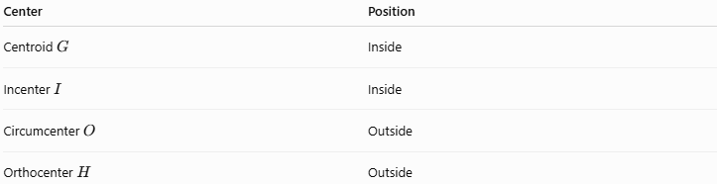
Center | Position
Centroid $G$ | Inside
Incenter $I$ | Inside
Circumcenter $O$ | Outside
Orthocenter $H$ | Outside
The four principal centers lie on the triangle's symmetry axis:
$$\boxed{G, I, O, H\text{ lie on the symmetry axis}}$$
The centroid, incenter, circumcenter, and orthocenter are generally distinct.

Euler Line
# Source: AI Source: Provided by: [Data Path: Persons Table -> ID Column: 1, Name_En Column: Motasem Essam] -> From: [ChatGPT] on [7/25/2026]
For a non-equilateral triangle, the circumcenter $O$, centroid $G$, and orthocenter $H$are collinear:
$$\boxed{O, G, H\text{ are collinear}}$$
Since the triangle is isosceles, the Euler line coincides with its symmetry axis.
The standard Euler-line relationship remains:
$$\boxed{OG:GH=1:2}$$
or
$$\boxed{GH=2OG}$$
and
$$\boxed{OH=3OG}.$$

Example
# Source: AI Source: Provided by: [Data Path: Persons Table -> ID Column: 1, Name_En Column: Motasem Essam] -> From: [ChatGPT] on [7/25/2026]
Consider a triangle with side lengths:
$$\boxed{5, 5, 8}$$
The two equal sides are:
$$5=5$$
so it is isosceles.
Check the longest side:
$$8^{2}=64$$
and
$$5^{2}+5^{2}=25+25=50.$$
Since
$$\boxed{64>50}$$
the triangle is obtuse.
Therefore, $5,5,8$forms an isosceles obtuse triangle.
Its angles are approximately:
$$\boxed{{36.87}^{∘}, {36.87}^{∘}, {106.26}^{∘}}$$
so the obtuse angle is approximately ${106.26}^{∘}$.

Comparison with Other Isosceles Triangles
# Source: AI Source: Provided by: [Data Path: Persons Table -> ID Column: 1, Name_En Column: Motasem Essam] -> From: [ChatGPT] on [7/25/2026]
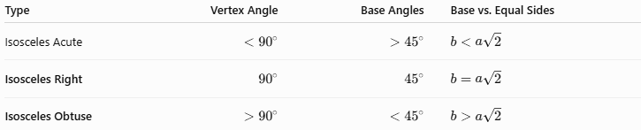
Type | Vertex Angle | Base Angles | Base vs. Equal Sides
Isosceles Acute | $$<{90}^{∘}$$ | $$>{45}^{∘}$$ | $$b<a\sqrt{2}$$
Isosceles Right | $${90}^{∘}$$ | $${45}^{∘}$$ | $$b=a\sqrt{2}$$
Isosceles Obtuse | $$>{90}^{∘}$$ | $$<{45}^{∘}$$ | $$b>a\sqrt{2}$$
This gives a useful transition:
$$\boxed{\text{Acute} → \text{Right} → \text{Obtuse}}$$
as the vertex angle increases through ${90}^{∘}$.

Classification
# Source: AI Source: Provided by: [Data Path: Persons Table -> ID Column: 1, Name_En Column: Motasem Essam] -> From: [ChatGPT] on [7/25/2026]
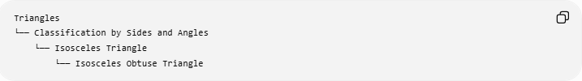
Triangles
└── Classification by Sides and Angles
└── Isosceles Triangle
└── Isosceles Obtuse Triangle
It can also be viewed through the two independent classification systems:
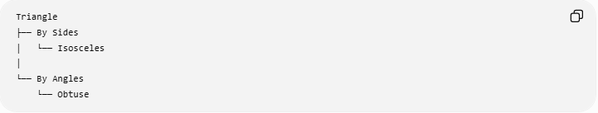
Triangle
├── By Sides
│ └── Isosceles
│
└── By Angles
└── Obtuse
Therefore:
$$\boxed{\text{Isosceles Obtuse Triangle}=\text{Isosceles by sides}+\text{Obtuse by angles}}$$

Key Points
# Source: AI Source: Provided by: [Data Path: Persons Table -> ID Column: 1, Name_En Column: Motasem Essam] -> From: [ChatGPT] on [7/25/2026]
- It has two equal sides.
- It has one obtuse angle.
- The obtuse angle is opposite the longest side, which is the base.
- The two base angles are equal and each is less than ${45}^{∘}$.
- It has one symmetry axis.
- The symmetry axis is simultaneously a median, altitude, angle bisector, and perpendicular bisector of the base.
- Its circumcenter and orthocenter are outside the triangle.
- Its centroid and incenter are inside.
- Its Euler line coincides with its symmetry axis.
- If equal sides are $a$and base is $b$:
$$\boxed{a\sqrt{2}<b<2a}$$
is the characteristic side-length condition.

Conclusion
# Source: AI Source: Provided by: [Data Path: Persons Table -> ID Column: 1, Name_En Column: Motasem Essam] -> From: [ChatGPT] on [7/25/2026]
An Isosceles Obtuse Triangle combines two classifications: it is isosceles by side lengths and obtuse by angle measure. Its defining geometric feature is an obtuse vertex angle opposite a base that is longer than either of the two equal sides. Its symmetry produces a particularly strong relationship among its median, altitude, angle bisector, perpendicular bisector, and triangle centers.

